

A STUDY ON WORKING CAPITAL MANAGEMENT

AT

HTL Ltd.,

Project report submitted in partial fulfilment of the requirements for the award of the Degree of

POST GRADUATE DIPLOMA IN MANAGEMENT AT
RAJALAKSHMI SCHOOL OF BUSINESS

By SANJAY. J
FTPGDM24104
Batch X, 2024-2026

Under the guidance of Dr. S. GAYATHRI
RAJALAKSHMI SCHOOL OF BUSINESS, CHENNAI

A STUDY ON WORKING CAPITAL MANAGEMENT OF HTL LTD

A SUMMER INTERNSHIP PROGRAM (SIP) REPORT 2025
Submitted by
SANJAY. J
RSB 24104
SIP at HTL Ltd
Under the guidance of
Dr. S. GAYATHRI
in partial fulfilment for the award of the degree of
Post Graduate Diploma in Management (PGDM)
Rajalakshmi school of business (RSB)
Kuthambakkam, Kanchipuram - Tamil Nadu 600124


APR-JUNE 2025

CERTIFICATE BY THE COMPANY

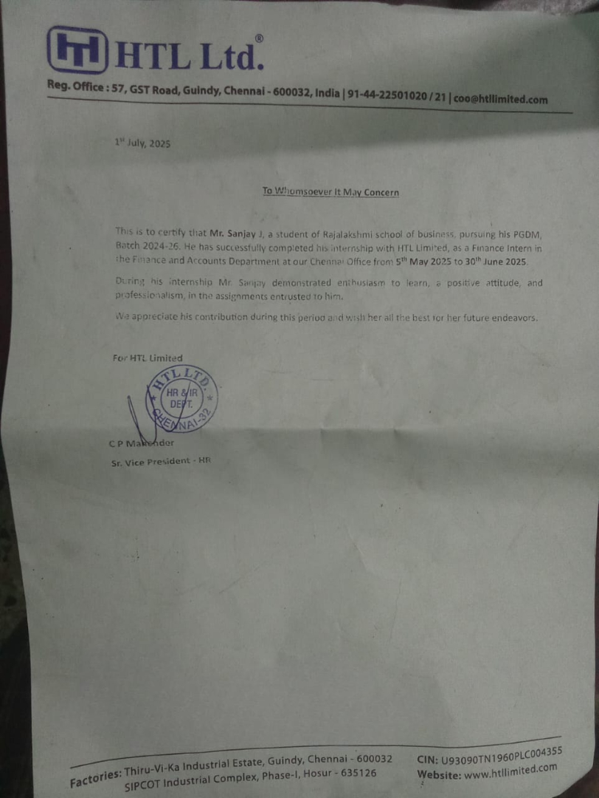



RAJALAKSHMI SCHOOL OF BUSINESS (RSB)
Kuthambakkam, Kanchipuram - Tamil Nadu 600124

CERTIFICATE FROM THE FACULTY MENTOR

This is to certify that this project report entitled “A study on the working capital management of HTL Ltd” submitted by Sanjay. J (RSB24014) is a Bonafide record of the research/project work done under my supervision. All the corrections pointed out by the Internal & External Evaluators have been incorporated in the final project and it fulfils the Rules & Regulations relating to the Summer Internship of the Institute.
This project has not been submitted to any other University or Institution for the award of any degree/diploma/certificate.
Dr. S. Gayathri
Signature with Date



RAJALAKSHMI SCHOOL OFBUSINESS (RSB)
Kuthambakkam, Kanchipuram - Tamil Nadu 600124

DECLARATION

I hereby declare that this Project report entitled “A study on the working capital management of HTL Ltd” submitted to the Rajalakshmi School of Business (RSB) in partial fulfilment of the requirements of PGDM Program is a Bonafide work carried by Sanjay. J under the guidance of Dr. S. Gayathri. This has not been submitted earlier to any other University or Institution for the award of any degree/diploma/certificate or published any time before.

Date :
Place :
Signature with Date
Sanjay. J
RSB24104

Acknowledgement:

I would like to thank Rajalakshmi School of Business for encouraging us to go on internships and gain practical experience.
I would like to thank Dr. Meenakshi Sundaram, Ph.D., CAO of Rajalakshmi School of Business for allowing me to go to HTL LTD.
I would like to thank Dr. Mahalakshmi, SIP mentor for facilitating this internship
I would like to thank Dr. S. Gayathri for mentoring me during the internship period.
I would like to thank Mr. Ponappa C.D (CFO) for granting me this internship, Mr. Parasuraman (Division manager) and Mr. Rajashekar (Division manager) for welcoming me and Mr. Sandeep (Payables accountant) for providing me on the job training and mentoring me during the internship period.

Index:

Table of contents

S. No | Title | Pg no.
1 | Abstract | 1
2 | Industry and company profile | 2
3 | Problem definition & Key Result Areas (KRAs) | 7
4 | Nature of responsibilities delegated by the company | 10
5 | Brief description of the assignment handed over | 14
6 | Description of accomplishments/achievements | 29
7 | Data analysis | 34
8 | Findings, recommendations and conclusions | 65
9 | References/bibliography | 69
10 | Appendices | 70
11 | Glossary | 81

List of tables

Table Number | Particulars | Page number
Table 1 | Snapshot of HTL financial performance | 4
Table 2 | SWOT analysis | 4
Table 3 | Competitor analysis for 2024 | 5
Table 4 | Theory vs organizational reality | 13
Table 5 | Snapshot of the balance sheets 2021-22, 2022-23 and 2023-24 | 34
Table 6 | Snapshot of the income statements 2021-22, 2022-23 and 2023-24 | 37
Table 7 | Comparative balance sheet statement for 2021-22 | 38
Table 8 | Comparative balance sheet statement of 2022-23 | 39
Table 9 | Comparative balance sheet statement of 2023-24 | 40
Table 10 | Comparative income statement of 2021-22 | 41
Table 11 | Comparative income statement of 2022-23 | 41
Table 12 | Comparative income statement of 2023-24 | 42
Table 13 | Snapshot of analytical ratios of 2020-21 and 2021-22 | 43
Table 14 | Snapshot of analytical ratios of 2021-22 and 2022-23 | 45
Table 15 | Snapshot of analytical ratios of 2022-23 and 2023-24 | 46
Table 16 | Summary of calculations | 62
Table 17 | Working capital metrics comparison 23-24 | 66

List of figures

Figure Number | Particulars | Page Number
Figure 1 | Current Assets vs Current Liabilities (Stacked Column) | 36
Figure 2 | Radar Chart - Efficiency and Liquidity (For FY 2024) | 47
Figure 3 | Turnover Ratios Comparison (Grouped Column) | 47
Figure 4 | Profitability Ratios (Line Chart) | 48
Figure 5 | Debt-to-Equity Ratio (Bar Chart) | 48
Figure 6 | Working capital Trend | 50
Figure 7 | Working Capital Turnover Trend | 52
Figure 8 | Current Ratio vs Quick Ratio (Multi-Line Chart) | 53
Figure 9 | CCC Components (DIO, DSO, DPO) | 67
Figure 10 | HTL Liquidity Efficiency Trend | 58
Figure 11 | Waterfall Chart: Cash Conversion Cycle Movement -FY 23 to FY 24 | 58
Figure 12 | CCC vs Operating Cycle | 60
Figure 13 | CCC Composition Pie Chart (For FY 2024) | 60
Figure 14 | HTL Year-on-Year CCC vs NPM vs Revenue (Bubble Chart) | 61
Figure 15 | Heat Map of Key Financial Ratios (21-24) | 64

Abstract (Executive summary):

This project focuses on evaluating the Working Capital Management practices at HTL Ltd., a prominent player in the telecom equipment manufacturing industry. The study was conducted to analyse how the company manages its short-term assets and liabilities to maintain operational efficiency and financial liquidity.
The research methodology adopted for this project included ratio analysis and examination of the company’s financial statements over a three-year period. Key metrics such as current ratio, quick ratio, working capital cycle, and inventory turnover were used to assess performance.
Findings reveal that while HTL Ltd. maintains a satisfactory liquidity position, challenges persist in receivables management and inventory holding patterns. These inefficiencies have an impact on cash flow and overall working capital turnover.
Based on the findings, this report recommends stricter credit control policies, better forecasting for inventory planning, and the adoption of digital dashboards for real-time monitoring. These measures could lead to improved cash flow, reduced working capital blockage, and enhanced financial agility.
The study highlights the critical role of efficient working capital management in ensuring a company's long-term financial sustainability and operational competitiveness.

Industry and Company Profile

Industry Profile – Indian Telecom & Optical Fiber Sector
HTL Ltd – Industry Snapshot
Core Business
HTL Ltd. (one of the largest private-sector players under HFCL Ltd.) specializes in integrated telecom products and solutions, focusing primarily on optical fiber cables (OFC) and related passive connectivity solutions.
Manufacturing Strengths
- A state-of-the-art facility in Chennai with an annual manufacturing capacity of 11.88 million fiber-kilometres of optical fiber cables.
- A Hosur facility that produces critical OFC raw materials, including Aramid/Kevlar rods, fiber-reinforced plastic rods (FRP), and impregnated glass fiber reinforcement (IGFR)
- Diversified Product Portfolio & Industry Focus
Beyond telecommunications, HTL has diversified into several adjacent and high-growth sectors:
- Telecom: Core offering of OFC and passive connectivity hardware.
- Aerospace & Defence: Manufacturing aerospace/military-grade fiber cables and Electrical Wiring Interconnect Solutions (EWIS).
- Automotive & Industrial: Producing wiring harnesses, power cables, and EV charger harnesses, serving two-wheeler, three-wheeler, cars, SUVs, tractors, and other industrial applications.
- Railways & Metro: Supplying telecom and signalling solutions for both urban transit and mainline freight corridors.
- Shipping: Providing cables, connectors, and assemblies for maritime applications.
- Power & Infrastructure: Supplying custom cable harnesses and end-to-end infrastructure services for telecom and industrial clients.
Porter's Five Forces Analysis
- Threat of New Entrants – Moderate
High capital requirements deter many entrants, though government support for digital initiatives lowers entry barriers for niche players.
- Bargaining Power of Suppliers – Moderate to High
Specialized raw materials and global supply chain dependencies give suppliers moderate leverage.
- Bargaining Power of Buyers – High
Telecom operators and public clients demand competitive pricing and customization, increasing buyer power.
- Threat of Substitutes – Low
Fiber optics have limited substitutes due to their superior speed and bandwidth.
- Industry Rivalry – High
Multiple players compete aggressively in pricing and project bidding, driving intense rivalry.

b) Company Profile – HTL Ltd.
History and highlights:
HTL Ltd. is a public sector enterprise under TCIL, originally founded in 1960. It transitioned from teleprinters to manufacturing optical fibre cables and telecom equipment. Its clientele includes government departments, PSUs, and telecom service providers.
Product Portfolio:
- Optical Fiber Cables (OFC)
- Transmission equipment and accessories

Key Financials (₹ Lakhs):
Table 1: Snapshot of HTL financial performance
Year | Revenue | Net Profit | WC | CCC (Days)
2021 | 64,303.93 | 2,850.44 | 6,154.73 | 80.1
2022 | 1,10,004.70 | 4,917.11 | 5,080.87 | 17.9
2023 | 1,26,441.06 | 6,459.52 | 10,463.29 | 73.63
2024 | 84,428.55 | 2,847.42 | 13.731.3 | 112.9

SWOT Analysis:
Table 2: SWOT analysis of HTL LTD
Strengths | Weaknesses
PSU backing, infrastructure, execution track record | High receivables, PSU dependency
Opportunities | Threats
BharatNet, FTTH growth | Competitive pricing, raw material cost swings

c) Market Positioning
Market share and current position:
HTL is a mid-tier OFC manufacturer catering mainly to public sector clients. While private players dominate in scale, HTL's PSU status and reliability help secure niche contracts.
Competitor analysis for 2024:
Table 3: Competitor analysis for 2024
Company | Revenue (₹ Lakhs) | NPM (%) | CCC (Days) | Working Capital | Working capital turnover ratio
HTL Ltd. | 84,428.55 | 3.38 | 112.9 | 13,731.3 | 6.15
HFCL Ltd. | 1,32,600 | 7.92 | 175 | 2,80,900.03 | 0.47
Sterlite Tech | 84,300 | 1.39 | -92 | 1,24,700 | 0.68
Source: www.screener.in; www.icicidirect.com.

d) Organizational Structure
HTL follows a functional structure, divided by core departments (Operations, Finance, SCM, Admin). Major decisions are top-down, with oversight from TCIL. This structure suits its tender-based business but limits agility.

e) Global and Indian Market Context
India:
Driven by BharatNet, 5G, Digital India, and Smart Cities, India is expanding its fibre network rapidly. Major players include Sterlite, HFCL, Aksh, and Finolex.
Global:
Global OFC leaders like Corning, Prysmian, and Furukawa are exploring Indian growth, but PSUs like HTL maintain relevance in government projects.

f) Sources
- HTL Annual Reports (FY22–FY24)
- HFCL Ltd Financials – Moneycontrol
- Sterlite Technologies – Moneycontrol
- Screener – HFCL
- DoT Website
- TCIL Reports and Ministry of Communications Press Releases

Problem Definition & Key Result Areas (KRAs)

Problem Definition:
The core focus of this project is to analyse and understand the working capital management practices of HTL Ltd. Efficient working capital management is crucial for maintaining liquidity, optimizing operational efficiency, and sustaining profitability. Given the dynamic nature of HTL's industry and financial environment, the challenge lies in assessing how effectively HTL manages its current assets and liabilities to support ongoing operations while minimizing financial costs and risks.

This project aims to evaluate HTL’s working capital through detailed analysis of its financial statements, including the balance sheet and income statement for the past several years, and by calculating and interpreting key financial ratios such as current ratio, quick ratio, debt-equity ratio, and several turnover ratios. A special focus is on understanding the fluctuations in the cash conversion cycle and related components like Days Inventory Outstanding (DIO), Days Sales Outstanding (DSO), and Days Payable Outstanding (DPO).

By objectively studying these metrics and trends, the project intends to identify strengths and potential areas for improvement in HTL's working capital management, thereby providing actionable insights that could support better financial decision-making and operational planning.

Key Result Areas (KRAs):

1. Data Collection and Financial Statement Analysis:
Gather and organize HTL’s financial data for the last three to four years from publicly available annual reports and internal financial documents.

2. Calculation and Interpretation of Working Capital Metrics:
Accurately compute working capital, working capital turnover, quick ratio, and other critical liquidity and efficiency ratios to gauge the company’s short-term financial health.

3. Analysis of Cash Conversion Cycle Components:
Analyse Days Inventory Outstanding, Days Sales Outstanding, Days Payable Outstanding, and the overall Cash Conversion Cycle to assess HTL’s operational efficiency.

4. Trend Analysis and Comparative Study:
Conduct year-over-year comparative analysis of ratios and working capital metrics to understand performance trends and pinpoint fluctuations or anomalies.

5. Charting and Visual Representation:
Develop clear charts and graphical representations of the financial data to enhance comprehension and support data-driven conclusions.

6. Consultation and Validation:
Engage with HTL’s finance team to validate findings, clarify uncertainties, and ensure accurate interpretation of data.

7. Comprehensive Reporting:
Compile a detailed report summarizing findings, insights, and recommendations focused on optimizing HTL’s working capital management.

8. Self-Directed Learning and Application:
Independently research and apply financial concepts, without formal training or direct mentorship, demonstrating self-motivation and initiative.

Nature of Responsibilities Delegated by the Company to the Student

a. Job Role Assigned
Was assigned the role of conducting a comprehensive analysis of the company's working capital management over a three-year period. The objective was to examine how effectively the company was managing its short-term assets and liabilities, and to identify trends or inefficiencies that might be affecting cash flow and liquidity.
This role involved:
- Studying audited financial statements from FY 2021–2024.
- Performing ratio analysis related to current assets, current liabilities, inventory, and receivables.
- Calculating and interpreting the Cash Conversion Cycle (CCC) and other liquidity indicators.
- Presenting data through tables, charts, and descriptive analysis.
Although not implementation-based, the role required critical financial thinking, structured data interpretation, and presentation of actionable insights.

b. Challenges Faced During the Assignment
Like most real-world internships, the assignment had its share of challenges:
- Limited Data: Some financial categories were aggregated in the statements, making ratio breakdowns and trend interpretations slightly more complex.
- No Access to real-time information: Did not have direct access to the company's ERP or real-time dashboards, so all analysis had to be based on static data.
- Benchmarking Difficulties: Obtaining accurate and up-to-date competitor data for ratio comparisons was difficult, as peer companies were either private or had limited disclosure.
- Ambiguity in Classification: Certain items (e.g., “other current liabilities”) required clarification before they could be correctly assigned in ratio calculations.

c. Strategies Used to Overcome These Challenges
To tackle these issues, several strategic approaches were adopted:
- Clarified Assumptions Through Discussions: regularly consulted with the finance team to clarify ambiguities in classification and confirm assumptions used in the analysis.
- Cross-Checked with Academic Sources: referred to internet to validate how working capital components should be treated in specific scenarios.
- Built a Structured Working File: maintained a master Excel and Word sheet to consistently track each metric, assumption, and source of information.
This structured and proactive approach helped ensure accuracy, despite limitations.

d. Classroom Topics That helped Strategize:
Several concepts from the PGDM curriculum proved directly useful during the internship:
- Ratio Analysis: Taught in Financial Accounting and Reporting, this formed the core methodology of the analysis.
- Vertical financial statements: Taught in Financial Accounting and Reporting, helped interpret modern balance sheet and income statements.
- Working capital: Taught in corporate finance, helped to understand the concept theoretically.
- Documenting Assumptions Transparently: A great practice picked up in class— noting every assumption made in analysis and sharing it clearly in the final report.

e. Concepts Learned During the Internship (Beyond the Classroom)
The internship also introduced real-world concepts that went beyond textbook learning:
- Working Capital Cycle (WCC): The model of DSO, DIO, and DPO helped guide diagnosis of cash flow inefficiencies.
- Comparative Statement Analysis: A key tool in identifying year-over-year movement and linking trends across financial components.
- Classification Judgment in Practice: Understanding how companies interpret and group line items differently in internal vs. external reporting.
- Industry-Specific Working Capital Norms: came to appreciate that ideal ratios vary not just by company size but by sector type, operational model, and credit ecosystem.

f. Academic Theory vs. Organizational Reality — A Comparative Reflection
Table 4: Theory vs organizational reality
Aspect | Academic Learning | Organizational Reality
Data Availability | Clean, structured, and pre-classified | Fragmented, and sometimes lacking classification clarity
Financial Ratios | Presented as clear-cut, definitive indicators | Used as starting points, often needing contextual interpretation
Working Capital Cycle | Taught just the basics | In reality, affected by customer behavior, vendor dynamics, and delays
SOP Adherence | Assumed to be followed strictly | Often aspirational — practice may vary department-wise
Departmental Coordination | Considered seamless | In practice, inter-department silos and data-sharing lags can occur

This comparison helped bridge the gap between theory and practice — and understand why financial decision-making is as much about judgment as it is about math.

Brief Description of the Assignment Handed Over Including Targets and Time Frame

a) The Type of Work Assigned to the Student

1. Study and Understand HTL Ltd.’s Financial Reports
First responsibility involved collecting the Balance Sheets, Income Statements, and Notes to Accounts from HTL’s Annual Reports over three consecutive years. This raw financial data formed the backbone of all subsequent tasks.
- Had to identify and extract data pertaining to Current Assets, Current Liabilities, Net Sales, Inventories, Receivables, Payables, and Short-term borrowings, among others.
- The task demanded a close reading of each line item and an understanding of how these figures interconnected to reflect liquidity and operational performance.
2. Perform a Full-Fledged Working Capital Analysis
Once the necessary data had been compiled, the task was with performing a series of financial ratio analyses and working capital evaluations to determine the efficiency of HTL Ltd.’s financial operations. The following key ratios were included:
Core Working Capital Ratios:
- Net Working Capital (NWC)
- Working Capital Turnover Ratio
- Current Ratio
- Quick Ratio, and so on

3. Create Visual Data Representations
Another important task involved representing the analysis using graphs, bar charts, and trend lines to visualize year-on-year changes
.
4. Interpret Data and Offer Insights
Beyond the calculations, the role was also analytical — had to interpret what the figures meant in practical terms. For instance:
- Was the company becoming more or less efficient in managing its receivables?
- Were payables being stretched to optimize liquidity, or indicating payment issues?
- an increasing CCC reflect poor inventory turnover, or market sluggishness?.

5. Compile the Analysis into a Structured Report
Finally, was responsible for organizing the entire process — from raw data to ratio analysis, from charts to insights — into a comprehensive report. The goal was to:
- Provide a clear summary of financial health across three years
- Identify strengths and concerns in working capital practices
- Suggest potential areas of improvement based on trends and benchmarks

b) The Schedule of Anticipated Activities Throughout the Duration of the Project
Before beginning the internship at HTL Ltd., had a straightforward yet meaningful plan in mind — a two-pronged focus:
- To deepen understanding of financial concepts and real-world practices, particularly in the area of working capital management, through active observation, independent research, and self-guided learning.
- To complete a comprehensive project analysing HTL Ltd.’s working capital efficiency using relevant financial tools, ratios, and interpretation techniques.

Phase 1: Immersion and Conceptual Understanding
(Self-guided and research-based – flexible over initial days)
In the early days of internship, the goal was to immerse myself in the broader landscape of financial operations. Since the company was entered without prior corporate exposure, the contextual knowledge around key financial processes had to be gradually built.
This included:
- Exploring how financial departments within companies function in a real-world setting.
- Observing how financial statements are structured, how frequently they are referenced in internal discussions, and how they serve different departments (accounting, procurement, senior management).
- Familiarizing myself with working capital as a concept, which involved:
  - Understanding its components: current assets, current liabilities, receivables, payables, inventory, and short-term borrowings.
  - Reading finance literature, blogs, research papers, and educational videos to reinforce foundational understanding.
  - Learning how businesses maintain a balance between liquidity and profitability using working capital strategies.

Phase 2: Project Execution – Working Capital Analysis
(Main project focus – continuous, exploratory, and analytical)
The second—and primary—part of plan centred around the successful completion of project:
“A Study on Working Capital Management at HTL Ltd.”
This was not a textbook exercise; it was a hands-on analysis using the company’s real financial data. The plan here was simple, yet rich in intent and depth. envisioned the following steps, not as calendar-bound appointments, but as organic stages of a journey:
• Collect Annual Reports and Extract Data
intended to gather three years’ worth of HTL Ltd.’s annual reports and extract key numbers from the balance sheet and income statement, especially those tied to:
- Current Assets (cash, receivables, inventory, etc.)
- Current Liabilities (trade payables, provisions, borrowings)
- Sales, cost of goods sold, net profit

c) Actual Timeline of Activities Performed
Unlike many internships that follow a pre-scheduled plan or rigid activity calendar, internship at HTL Ltd. was more agile and self-directed in nature. The execution phase was designed around actual progress and personal milestones, rather than a strict day-wise checklist. What follows is a clear account of the tasks performed, day by day and week by week, reflecting both the real-time flow and organic evolution of project.

Day 1: Setting the Stage – Data Collection and Structural Framing
first day at HTL Ltd. was dedicated to laying the foundation for the entire project. began by sourcing the last three years of annual reports of the company. These reports were essential as they contained the Balance Sheets, Profit & Loss Accounts, and Notes to Accounts – the raw material required for working capital analysis.
During the same day, also focused on:
- Understanding HTL Ltd.’s business environment and operational structure
- Reading through the Management Discussion and Analysis (MD&A) sections to get a pulse on the company’s strategic direction
- Taking note of key working capital components: receivables, inventory, payables, borrowings, and current liabilities
- Structuring spreadsheet framework to accommodate tabular financial data
- Listing the relevant ratios and analysis points to be computed in later stages
The day revolved more around comprehension and preparation than calculation — but this mental mapping was vital to ensure smooth execution in the days to come.

Day 2: Number Crunching Begins – Tabular Work and Ratio Computation
The second day marked a full-fledged transition into data analysis. Armed with the numerical data extracted from the reports, began organizing the financial information into well-labelled, year-wise tables.
Tasks performed:
- Segregated values for Current Assets, Current Liabilities, Inventories, Trade Receivables, Trade Payables, and Short-term Borrowings
- Constructed comprehensive tables for each of the three years, ensuring consistency in format and formulae
- Performed all ratio computations

Days 3–5: Visualization, Verification, and Value-Addition
While the base work had been wrapped up in the first two days, the remaining part of the week was spent enriching the report — turning dry data into digestible, meaningful insights.
On Day 3, focused on:
- Creating visual charts for each key metric: bar graphs for year-wise ratios, pie charts for asset composition, and line graphs for trend observations
- Organizing visuals aesthetically with proper labelling and consistency
- Highlighting key ratio movements through color-coded visual elements

On Days 4 and 5, devoted time to:
- Cleaning and refining tables and visuals — checking for alignment, formatting, and presentation consistency
- Consulting members of the finance department to clarify job roles, organizational structure for the company profile part.
- Validating interpretations of the ratios — ensuring that content written is correct.

d) A Description of the Relevant Training Provided to the Student During the Internship
Although the internship at HTL Ltd. not involve any structured or formal training sessions, learning during this period was both rich and continuous, shaped by a mix of self-initiated research, observational learning, and interactive clarification with members of the finance team.

Self-Directed Learning: Personal Finance Bootcamp
With no training manual in hand, it was built using:
- Online resources: Professional articles to gain practical clarity on real-world applications of working capital theory.
- Annual reports of HTL Ltd., not just as raw data but as a learning resource by itself.
This method gave a better sense of how financial terms are used in practice versus in theory. It also forced one to learn actively, rather than passively consume information.

Observation as a Learning Tool
In a dynamic office environment, learning doesn’t always come from a whiteboard — sometimes, it comes from watching:
- How finance professionals handle real financial statements
- The way internal documents are structured, referenced, and updated
- The software tools and Excel functions in action while reviewing financials
Quietly observed the nuances — how line items are verified, how assumptions are challenged, how conclusions are drawn — and internalized these subtleties into approach.

Learning by Doing – The Most Effective Training Method
At its core, this internship trained through real work. There’s no better classroom than a spreadsheet filled with live data and a report deadline breathing down your neck.
By performing tasks such as:
- Extracting and organizing three years of financial data
- Computing and interpreting 10+ key financial ratios
- Visualizing those results meaningfully
- Drawing real insights from raw numbers

e) A Detailed Explanation of the Important Tasks Involved in Performing the Job
The internship project, titled “A Study on Working Capital Management of HTL Ltd.”, might sound neat and tidy on the surface, but executing it involved a multitude of intricately connected tasks — all orbiting around the universe of financial data, analysis, and interpretation.

1. Collection and Extraction of Financial Data
Objective: Gather accurate financial information from reliable sources
Execution:
- accessed three consecutive annual reports (FY 2020–21, 2021–22, 2022–23) from HTL Ltd.’s public disclosures and internal archives.
- Navigated through the Balance Sheet, Income Statement, and Notes to Accounts, cross-checking each figure to ensure authenticity.
- Identified relevant figures such as:
  - Current Assets: Inventories, Trade Receivables, Cash and Cash Equivalents
  - Current Liabilities: Trade Payables, Short-Term Borrowings, Other Current Liabilities

2. Computation of Financial Ratios & Working Capital Metrics
This was the analytical heart of the project. Here’s a breakdown of some of the ratios calculated and their purpose:
a) Liquidity Ratios:
- Current Ratio: Measures short-term financial health
  - Formula: Current Assets / Current Liabilities
- Quick Ratio: Measures immediate liquidity without inventory
  - Formula: (Current Assets – Inventory) / Current Liabilities
b) Turnover Ratios:
- Inventory Turnover Ratio: Assesses how efficiently inventory is converted to sales
  - Formula: Cost of Goods Sold / Average Inventory
- Trade Receivables Turnover Ratio: Measures efficiency in collecting receivables
  - Formula: Net Credit Sales / Average Receivables
- Trade Payables Turnover Ratio: Evaluates how quickly the company pays its suppliers
  - Formula: Net Credit Purchases / Average Payables
- Net Working Capital Turnover: Indicates revenue generated per unit of working capital
  - Formula: Net Sales / Average Net Working Capital
3. Visualizing Data with Graphs and Charts
Numbers speak, but visuals shout.
To make the data more engaging and digestible:
- created:
  - Line graphs to show year-on-year ratio trends
  - Bar charts for comparison of major current assets/liabilities
  - Pie charts to display asset/liability composition

4. Interpretation and Insight Development
Numbers alone don’t tell a story unless interpreted meaningfully. After computation and visualization:
- analysed the implications of rising or falling ratios
- Compared trends across the three years

f) Description of the Tasks or Objectives That Were Accomplished
Despite the relatively short duration of the project work, a significant and satisfying volume of meaningful work was completed — with each task tying back to the core objective of financial insight and operational clarity.
1. Full Extraction and Compilation of Financial Data (3 Years)
Accomplishment: successfully identified, extracted, and organized all relevant financial data across a span of three fiscal years — FY 2020–21, FY 2021–22, and FY 2022–23.
- Source documents included: Balance Sheets, Profit & Loss Statements, Notes to Accounts
- Data cleaning and error checks ensured consistency and completeness across the years

2. Tabular Analysis and Working Capital Calculations
Accomplishment: computed all critical working capital figures with clear year-wise tables. The following were calculated:
- Net Working Capital (NWC)
- Current Assets vs. Current Liabilities comparisons
- Year-on-Year changes and comparative tables

3. Ratio Computation and Financial Metric Analysis
Accomplishment: carried out detailed computation of over a dozen financial ratios and metrics, all tied to working capital efficiency, liquidity, turnover, and profitability. Inventory Turnover Ratio.

4. Data Visualization through Charts & Graphs
Accomplishment: transformed raw numbers into clear, insightful visuals:
- Line charts showing changes in key ratios across the three years
- Bar graphs comparing various turnover metrics
- Pie charts breaking down current assets and liabilities
- Color-coded formatting for instant interpretability

5. Interpretation of Findings and Drafting of Insights
Accomplishment: wrote extensive commentary on the implications of analysis, covering:
- Strengths and weaknesses in working capital structure
- Efficiency of inventory and receivables handling
- Liquidity buffers and short-term financial strategy
- Alignment (or deviation) from industry benchmarks

g) List of Tasks That the Student Was Unable to Accomplish as an Intern
While the internship experience at HTL Ltd. was rich in learning and achievement, it is important to acknowledge certain tasks and areas that, due to constraints of time, scope, and position, could not be fully undertaken.
These limitations, while not detracting from the core objectives of the project, are presented below as part of a transparent and honest review of the internship experience:

1. In-depth Departmental Interaction Across All Divisions
Though interacted with the finance team for clarifications and verification of data, was not able to conduct extensive, structured interviews or shadow professionals across departments like procurement, inventory control, and sales. Such interactions could have offered deeper operational insights into working capital movement from a process-based perspective.

2. Access to Internal Software Systems and ERP Tools
Due to company policy and data confidentiality, was not granted access to internal ERP platforms (like SAP, Oracle, or Tally). As a result, all financial data had to be sourced from static annual reports and not from live transaction-level systems, limiting real-time understanding of cash flows and capital cycles.

3. Real-time Observation of Working Capital Decisions
Working capital decisions — like altering supplier credit terms or adjusting inventory purchase timing — are dynamic and often taken by senior finance managers. As an intern, was not in a position to observe or participate in these real-time decisions or attend strategy-level discussions.

4. Benchmarking Against Industry Peers
While HTL Ltd.’s financials were analysed in detail, due to lack of access to comparable financial statements of direct competitors, could not conduct a rigorous benchmarking exercise or relative performance study. This would have provided a broader industry context to the findings.

5. Review of Cash Management and Short-term Investment Practices
Though current assets and liabilities were studied, did not have the opportunity to deeply examine HTL Ltd.’s policies on short-term surplus investments, bank dealings, or idle cash strategies — which are often crucial parts of overall working capital efficiency.

Description of Accomplishments/Achievements with Facts and Figures

a) Overview of the Project and Its Scope
During internship at HTL Ltd, a comprehensive financial analysis focusing on the company’s working capital management over a four-year span from 2020-21 to 2023-24 was undertook. The project aimed to evaluate liquidity, operational efficiency, and profitability by studying key financial metrics, thus providing a multi-faceted view of the company’s short-term financial stability and operational dynamics. A significant challenge was synthesizing complex financial data from multiple periods, ensuring accuracy and relevance, all while working independently without formal training.

b) Specific Role and Responsibilities
was entrusted with the entire analytical process—from data extraction from annual reports to manual computation of vital financial ratios and working capital metrics. responsibilities included:
- Collecting and organizing extensive multi-year financial data.
- Calculating numerous financial ratios including Current Ratio, Debt-Equity Ratio, Debt-Service Coverage, Inventory Turnover, Trade Receivables Turnover, Trade Payables Turnover, Net Capital Turnover, Return on Equity, Net Profit Ratio, Return on Capital Employed, and others.
- Analysing trends through comparative year-on-year variance to assess financial health and operational efficiency shifts.
- Preparing detailed tables and charts to visually communicate findings.
- Coordinating with the finance team to validate data and clarify financial nuances.
- Documenting observations and drafting the final report in MS Word.

c) Key Accomplishments with Facts and Figures

Ratio Calculations and Trend Analysis:
Successfully computed an extensive suite of ratios, tracking performance across three comparative periods. For example, the Current Ratio showed improvement by 18.11% from 1.16 (2021-22) to 1.37 (2022-23), indicating enhanced liquidity. The Debt-Equity Ratio impressively dropped by 60.50% over two periods (from 14.46 to 5.71, and then to 1.17), reflecting a strategic reduction in reliance on debt financing.
- Profitability Insights:
Despite fluctuations, the Net Profit Ratio demonstrated positive trends with a 11.59% increase from 2020-21 to 2021-22 and steady figures thereafter, while Return on Equity, although declining by 50.09% from a high 182% in 2020-21, still indicated strong equity returns over the years analysed.
- Operational Efficiency:
Inventory Turnover Ratio improved by 7.84% in 2022-23 compared to the prior period, while Trade Receivables Turnover increased by 26.56%, signalling better asset utilization. However, the Net Capital Turnover ratio saw a decrease of 9.55% over the same period, inviting further analysis.
- Working Capital Metrics:
Working capital itself showed a consistent upward trend, growing from ₹6,154.73 lakhs in 2021 to ₹13,731.3 lakhs in 2024. Days Inventory Outstanding and Days Sales Outstanding displayed notable volatility, suggesting areas for potential optimization. The Cash Conversion Cycle increased to 112.9 days in 2024, highlighting opportunities to accelerate cash flow cycles.
- Visual Data Representation:
Created detailed charts to illustrate fluctuations in key metrics like Days Payable Outstanding, Operating Cycle, and Working Capital Turnover, making complex data accessible and actionable for the finance team.

Key achievements and skills gained:
  - Independently calculated over 15+ working capital metrics, including CCC, DIO, DSO, DPO, and turnover ratios across two fiscal years.
  - Verified data across three annual reports using balance sheet reconciliation and notes to accounts.
  - Developed deep understanding of working capital mechanics, financial statement interpretation, and practical business liquidity issues.

d) Contributions to Process Improvements and Cost Insights
While role was primarily analytical and observational, detailed ratio analyses and trend assessments provided HTL’s finance department with clear indicators of areas for operational efficiency gains and risk management. Insights such as the notable decrease in Debt-Equity Ratio point toward enhanced financial stability, while increases in Cash Conversion Cycle suggest opportunities to streamline receivables and inventory processes to improve liquidity and reduce financing costs.

e) Improvements in Collaboration and Communication
Throughout the internship, independently initiated communication with the finance team to clarify data points and ensure accuracy. This fostered a collaborative atmosphere despite the absence of formal supervision, demonstrating self-starting nature and ability to navigate organizational processes efficiently.

f) Skills Developed
- Technical: Mastered complex ratio computations manually, enhancing analytical precision and understanding of corporate finance metrics. Developed proficiency in organizing and presenting financial data using MS Word.
- Soft Skills: Strengthened communication and interpersonal skills through proactive engagement with finance professionals. Demonstrated strong self-motivation, initiative, and project management discipline.
- Industry Knowledge: Gained an in-depth understanding of working capital management’s role in sustaining operational and financial health within a manufacturing firm.

g) Broader Impact on Organization
Analytical report offers HTL Ltd. a solid financial snapshot across multiple years, pinpointing both strengths and areas ripe for improvement. These insights support the company’s strategic objectives around liquidity optimization and cost control, adding tangible value to ongoing financial management efforts.

h) Feedback and Recognition
Though no formal awards were conferred, work was met with appreciation by the finance team for its accuracy, clarity, and professional attitude. Positive feedback affirmed contributions and encouraged further exploration of financial analysis as a career path.

i) Summary and Personal Reflection
This internship has been an invaluable stepping stone in professional journey, blending theory with practice. It challenged to work autonomously, sharpen analytical rigor, and develop effective communication strategies in a corporate environment. The experience solidified interest in financial management and equipped with skills that will serve as a foundation for future growth.

Data analysis:

📌 Note: Where discrepancies exist between prior year closing balances and current year opening balances, the amounts from the latest financial statement (.e., 2022–23) have been considered. This ensures alignment with current accounting disclosures and reflects any adjustments or reclassifications made post final audit.
📌 Note 2: Certain total values in the company’s liabilities appear inconsistent with the rounded values provided in the table. The discrepancy may stem from the use of unrounded internal values.

Table 5: Snapshot of the balance sheets 2021-22, 2022-23 and 2023-24
Particulars | 2021 | 2022 | 2023 | 2024
Inventories | 12,772.32 | 16,385.62 | 17,245.53 | 13,259.59
Investments | 17.08 | 17.08 | 18.60 | 18.60
Trade receivables | 18,538.70 | 17,217.76 | 18,149.69 | 23,937.99
Cash & cash equivalents | 29.68 | 65.83 | 8.92 | 5.28
Bank balances other than above | 1,015.72 | 2,217.20 | 2,238.16 | 1,413.97
Others | 347.20 | 447.90 | 283.86 | 406.18
Current tax assets (Net) | - | 36.13 | 36.13 | 36.13
Other current assets | 809.12 | 947.01 | 1,010.62 | 877.70
Total current assets | 33,529.82 | 37,334.53 | 38,991.51 | 39,955.44
Borrowings | 5,948.69 | 11,632.78 | 11,663.70 | 12,314.26
Total outstanding dues of micro and small enterprises | 1,399.65 | 1,352.61 | 891.20 | 301.97
Total outstanding dues of creditors other than above | 18,754.81 | 14,325.58 | 9,939.03 | 10,092.20
Other financial liabilities | 523.52 | 3,756.97 | 3,600.52 | 1,234.46
Trade payables | 20,677.98 | 19,435.16 | 11,430.75 | 11,628.63
Other current liabilities | 313.75 | 193.47 | 720.77 | 1,777.58
Provisions | 31.31 | 34.02 | 24.28 | 29.18
Current tax liabilities (Net) | 403.36 | 968.23 | 1,688.71 | 474.49
Total current liabilities | 27,375.09 | 32,263.66 | 28,528.22 | 26,224.14

Figure 1: Current Assets vs Current Liabilities (Stacked Column)

Table 6: Snapshot of the income statements 2021-22, 2022-23 and 2023-24
Particulars | 2021 | 2022 | 2023 | 2024
Revenue from operations | 64,303.93 | 1,10,004.70 | 1,26,441.06 | 84,428.55
Cost of materials consumed | 47,986.24 | 76,771.70 | 92,723.53 | 59,272.71
Other direct cost | 584.76 | 1,023.34 | 1,272.62 | 1,253.13
Purchases of stock-in-trade | 3,513.11 | 4,060.10 | 5,592.02 | 684.82
Changes in inventories of finished goods, work-in-progress and Stock-in-Trade | -2002.04 | -1,510.11 | 348.73 | 2,056.31
Cost of Goods Sold | 1,14,386 | 80,345.03 | 99,936.9 | 63,266.97

Table 7: Comparative balance sheet statement for 2021-22

Particulars | 2021 | 2022 | Absolute | Percentage
Inventories | 12,772.32 | 16,385.62 | 3,613.3 | 28.29%
Investments | 17.08 | 17.08 | 0 | 0%
Trade receivables | 18,538.70 | 17,217.76 | -1,320.94 | -7.13%
Cash & cash equivalents | 29.68 | 65.83 | 36.15 | 121.80%
Bank balances other than above | 1,015.72 | 2,217.20 | 1,201.48 | 118.29%
Others | 347.20 | 447.90 | 100.7 | 29%
Current tax assets (Net) | - | 36.13 | 36.13 | -
Other current assets | 809.12 | 947.01 | 137.89 | 17.04%
Total current assets | 33,529.82 | 37,334.53 | 3,804.71 | 11.35%
Borrowings | 5,948.69 | 11,632.78 | 5,684.09 | 95.55%
Total outstanding dues of micro and small enterprises | 1,399.65 | 1,352.61 | -47.04 | -3.36%
Total outstanding dues of creditors other than above | 18,754.81 | 14,325.58 | -4,429.23 | -23.62%
Other financial liabilities | 523.52 | 3,756.97 | 3,233.45 | 617.64%
Other current liabilities | 313.75 | 193.47 | -120.28 | -38.34%
Provisions | 31.31 | 34.02 | 2.71 | 8.66%
Current tax liabilities (Net) | 403.36 | 968.23 | 564.87 | 140.04%
Total current liabilities | 27,375.09 | 32,263.66 | 4,888.57 | 17.86%

Table 8 : Comparative balance sheet statement of 2022-23
Particulars | 2022 | 2023 | Absolute | Percentage
Inventories | 16,385.62 | 17,245.53 | 859.91 | 51.01%
Investments | 17.08 | 18.60 | 1.52 | 8.90%
Trade receivables | 17,217.76 | 18,149.69 | 932.14 | 5.41%
Cash & cash equivalents | 65.83 | 8.92 | -56.91 | -86.49%
Bank balances other than above | 2,217.20 | 2,238.16 | 20.96 | 0.95%
Others | 447.90 | 283.86 | -164.04 | -36.62%
Current tax assets (Net) | 36.13 | 36.13 | 0 | 0%
Other current assets | 947.01 | 1,010.62 | 63.61 | 6.72%
Total current assets | 37,334.53 | 38,991.51 | 1,656.98 | 4.44%
Borrowings | 11,632.78 | 11,663.70 | 30.92 | 0.27%
Total outstanding dues of micro and small enterprises | 1,352.61 | 891.20 | -461.41 | -34.11%
Total outstanding dues of creditors other than above | 14,325.58 | 9,939.03 | -13,386.55 | -93.45%
Other financial liabilities | 3,756.97 | 3,600.52 | -156.45 | -4.16%
Other current liabilities | 193.47 | 720.77 | 527.3 | 272.55%
Provisions | 34.02 | 24.28 | -9.74 | -28.63%
Current tax liabilities (Net) | 968.23 | 1,688.71 | 720.48 | 74.41%
Total current liabilities | 32,263.66 | 28,528.22 | -3,735.44 | -11.58%

Table 9: Comparative balance sheet statement of 2023-24
Particulars | 2023 | 2024 | Absolute | Percentage
Inventories | 17,245.53 | 13,259.59 | -3,985.94 | -23.11%
Investments | 18.60 | 18.60 | 0 | 0%
Trade receivables | 18,149.69 | 23,937.99 | 5,788.3 | 31.89%
Cash & cash equivalents | 8.92 | 5.28 | -3.64 | -40.81%
Bank balances other than above | 2,238.16 | 1,413.97 | -824.19 | -36.82%
Others | 283.86 | 406.18 | 167.32 | 58.94
Current tax assets (Net) | 36.13 | 36.13 | 0 | 0%
Other current assets | 1,010.62 | 877.70 | -132.92 | -13.15%
Total current assets | 38,991.51 | 39,955.44 | 964.34 | 2.47%
Borrowings | 11,663.70 | 12,414.26 | 750.56 | 6.44%
Total outstanding dues of micro and small enterprises | 891.20 | 301.97 | -589.23 | -66.12%
Total outstanding dues of creditors other than above | 9,939.03 | 10,092.20 | 153.17 | 1.54%
Other financial liabilities | 3,600.52 | 1,234.46 | -2,366.06 | -65.71%
Other current liabilities | 720.77 | 1,777.58 | 1,056.81 | 146.62%
Provisions | 24.28 | 29.18 | 4.9 | 20.18%
Current tax liabilities (Net) | 1,688.71 | 474.49 | -1,214.22 | -71.90%
Total current liabilities | 28,528.22 | 26,224.14 | -2,304.08 | -8.08%

Table 10: Comparative income statement of 2021-22
Particulars | 2021 | 2022 | Absolute | Relative
Revenue from operations | 64,303.93 | 1,10,004.70 | 45,700.77 | 71.07%
Cost of materials consumed | 47,986.24 | 76,771.70 | 28,785.46 | 59.99%
Other direct cost | 584.76 | 1,023.34 | 438.58 | 75.00%
Purchases of stock-in-trade | 3,513.11 | 4,060.10 | 546.99 | 15.57%
Changes in inventories of finished goods, work-in-progress and Stock-in-Trade | -2002.04 | -1,510.11 | 491.93 | -24.57%
Cost of Goods Sold | 1,14,386 | 80,345.03 | -34,040.97 | -29.76%

Table 11: Comparative income statement of 2022-23
Particulars | 2022 | 2023 | Absolute | Relative
Revenue from operations | 1,10,004.70 | 1,26,441.06 | 16,436.36 | 14.94%
Cost of materials consumed | 76,771.70 | 92,723.53 | 15,951.83 | 20.78%
Other direct cost | 1,023.34 | 1,272.62 | 249.28 | 24.36%
Purchases of stock-in-trade | 4,060.10 | 5,592.02 | 1,531.92 | 37.73%
Changes in inventories of finished goods, work-in-progress and Stock-in-Trade | -1,510.11 | 348.73 | 1,858.84 | -123.09%
Cost of Goods Sold | 80,345.03 | 99,936.9 | 19,591.87 | 24.38%

Table 12: Comparative income statement of 2023-24
Particulars | 2023 | 2024 | Absolute | Relative
Revenue from operations | 1,26,441.06 | 84,428.55 | -42,012.51 | -33.23%
Cost of materials consumed | 92,723.53 | 59,272.71 | -33,450.82 | -36.08%
Other direct cost | 1,272.62 | 1,253.13 | -19.49 | -1.53%
Purchases of stock-in-trade | 5,592.02 | 684.82 | -4,907.2 | -87.75%
Changes in inventories of finished goods, work-in-progress and Stock-in-Trade | 348.73 | 2,056.31 | 1,707.58 | 489.66%
Cost of Goods Sold | 99,936.9 | 63,266.97 | -36,669.93 | -366.81%

Note: Certain percentage variances in the company’s analytical ratios (e.g., Current Ratio and Inventory Turnover) appear inconsistent with the rounded values provided in the table. Based on recalculation using visible figures, the variance in the Current Ratio is approximately –4.92%, not –5.51% as stated. The discrepancy may stem from the use of unrounded internal values or typographical inconsistencies.
Note 2: The reported percentage change for Debt – equity ratio and Inventory Turnover ratio appears to be misstated in the original financial report. Upon recalculation, the actual variance is -60.50% and +8.59%, indicating a mistake in the sign.

Table 13: Snapshot of analytical ratios of 2020-21 and 2021-22
Ratios | Current Period (2021 - 22) | Previous Period (2020 – 21) | % Variance
Current ratio | 1.16 | 1.22 | -5.51%
Debt-equity ratio | 5.71 | 14.46 | -60.50%
Debt-service coverage ratio | 8.87 | 10.92 | -18.81%
Inventory turnover ratio | 5.44 | 5.01 | 8.59%
Trade receivables turnover ratio | 5.65 | 4.21 | 34.28%
Trade payables turnover ratio | 4.27 | 3.56 | 20.13%
Net capital turnover ratio | 18.00 | 14.53 | 23.88%
Return on equity ratio | 90.84% | 182% | -50.09%
Net profit ratio | 4.87% | 4.37% | 11.59%
Return on capital employed | 54.47% | 42.55% | 28.01%
Return on investment | N. A | N. A | -

Note: The reported percentage change for Inventory Turnover ratio appears to be misstated in the original financial report. Upon recalculation, the actual variance is ~+7.90%, indicating a mistake in the sign.
Table 14: Snapshot of analytical ratios of 2021-22 and 2022-23
Ratios | Current Period (2022 - 23) | Previous Period (2021 – 22) | % Variance
Current ratio | 1.37 | 1.16 | 18.11%
Debt-equity ratio | 1.17 | 2.12 | -60.50%
Debt-service coverage ratio | 7.12 | 8.87 | -19.67%
Inventory turnover ratio | 5.87 | 5.44 | 7.84%
Trade receivables turnover ratio | 7.15 | 5.65 | 26.56%
Trade payables turnover ratio | 7.52 | 4.59 | 63.75%
Net capital turnover ratio | 16.28 | 17.99 | -9.55%
Return on equity ratio | 58.48% | 90.84% | -35.62%
Net profit ratio | 5.12% | 4.87% | 5.10%
Return on capital employed | 52.70% | 54.47% | -3.25%
Return on investment | N. A | N. A | -

Note: The reported percentage change for Debt-equity ratio and inventory turnover ratio appears to be misstated in the original financial report. Upon recalculation, the actual variance is ~-10.38% and ~-43.13% indicating a mistake in the sign.
Table 15: Snapshot of analytical ratios of 2022-23 and 2023-24
Ratios | Current Period (2023 - 24) | Previous Period (2022 – 23) | % Variance
Current ratio | 1.52 | 1.37 | 11.48%
Debt-equity ratio | 1.06 | 1.17 | -9.72%
Debt-service coverage ratio | 1.32 | 2.67 | -50.63%
Inventory turnover ratio | 4.15 | 5.94 | -30.21%
Trade receivables turnover ratio | 4.01 | 7.15 | -43.9%
Trade payables turnover ratio | 5.50 | 7.52 | -26.83%
Net capital turnover ratio | 6.97 | 16.28 | -57.15%
Return on equity ratio | 18.13% | 58.48% | -69.00%
Net profit ratio | 3.38% | 5.14% | -34.13%
Return on capital employed | 13.29% | 23.21% | -42.74%
Return on investment | N. A | N. A | -

Figure 2: Radar Chart - Efficiency and Liquidity (For FY 2024)

Figure 3: Turnover Ratios Comparison (Grouped Column)

Figure 4: Profitability Ratios (Line Chart)

Figure 5: Debt-to-Equity Ratio (Bar Chart)

Working capital formula:
$$Working capital =Current assets-current liabilities$$

Working capital for 2021:
$$Working Capital of 2021=33,529.82-27,375.09=6,154.73$$
Working capital for 2022:
$$Working capital of 2022=37,334.53-32,263.66=5,070.87$$

Working capital for 2023:
$$Working capital of 2023=38,991.51-28,528.22=10,463.29$$

Working capital for 2024:
$$Working capital of 2024=39,955.44-26,224. 14=13,731.3$$
Figure 6: Working capital Trend

Working capital turnover formula:
Note: Working Capital Turnover was calculated using Revenue from Operations as reported in the Statement of Profit and Loss. This figure excludes non-operating income to ensure alignment with the operational nature of working capital usage.

$$Working capital turnover= \frac{Revenue}{Working capital}$$

Working capital turnover for 2021:
$$Working capital turnover of 2021= \frac{64,303.93}{6,154.73}=10.45$$

Working capital turnover for 2022:
$$Working capital turnover of 2022= \frac{1,10,004.70}{5,070.87}=21.69$$

Working capital turnover for 2023:
$$Working capital turnover of 2023= \frac{1,26,441.06}{10,463.29}=12.08$$

Working capital turnover for 2024:
$$Working capital turnover of 2024= \frac{84,428.55}{13,731.3}=6.15$$
Figure 7: Working Capital Turnover Trend

Quick ratio formula:
$$Quick ratio=\frac{\left(Current assets-inventory\right)}{Current liabilities}$$

Quick ratio for 2021:
$$Quick ratio of 2021=\frac{\left(33,529.82-12,772.32\right)}{27,375.09}=0.76$$

Quick ratio for 2022:
$$Quick ratio of 2022=\frac{\left(37,334.53-16,385.62\right)}{32,263.66}=0.65$$

Quick ratio for 2023:
$$Quick ratio of 2023=\frac{\left(38,991.51-17,245.53\right)}{28,528.22}=0.76$$

Quick ratio for 2024:
$$Quick ratio of 2024=\frac{\left(39,955.44-13,258.59\right)}{26,224.14}=1.02$$

Figure 8: Current Ratio vs Quick Ratio (Multi-Line Chart)

Days Sales Outstanding formula:
$$Days Sales Outstanding =\left(\frac{Accounst receivable}{Revenue}\right) ×365$$

Days Sales Outstanding for 2021:
$$Days Sales Outstanding of 2021=\left(\frac{18,538.70}{64,303.93}\right) ×365=105.23$$

Days Sales Outstanding for 2022:
$$Days Sales Outstanding of 2022=\left(\frac{17,217.76}{1,10,004.70}\right) ×365=57.13$$

Days Sales Outstanding for 2023:
$$Days Sales Outstanding of 2023=\left(\frac{18,149.69}{1,26,441.06}\right) ×365=52.39$$

Days Sales Outstanding for 2024:
$$Days Sales Outstanding of 2024=\left(\frac{23,937.99}{84,428.55}\right) ×365=103.49$$

Days Inventory Outstanding formula:
$$Days Inventory Outstanding=\left(\frac{Inventory}{COGS}\right)×3$$
Days Inventory Outstanding for 2021:
$$Days Inventory Outstanding of 2021=\left(\frac{12,772.32}{1,14,386}\right)×365=40.76$$

Days Inventory Outstanding for 2022:
$$Days Inventory Outstanding of 2022=\left(\frac{16,385.62}{80,345.03}\right)×365=13.26$$

Days Inventory Outstanding for 2023:
$$Days Inventory Outstanding of 2023=\left(\frac{17,245.53}{99,936.9}\right)×365=62.99$$

Days Inventory Outstanding for 2024:
$$Days Inventory Outstanding of 2024=\left(\frac{13,259.59}{63,266.97}\right)×365=76.50$$

Days Payables Outstanding:
$$Days Payables Outstanding=\left(\frac{Accounts payable}{COGS}\right)×365$$

Days Payables Outstanding for 2021:
$$Days Payables Outstanding of 2021=\left(\frac{20,677.98}{1,14,386}\right)×365=65.98$$
Days Payables Outstanding for 2022:
$$Days Payables Outstanding of 2022=\left(\frac{19,435.16}{80,345.03}\right)×365=88.29$$

Days Payables Outstanding for 2023:
$$Days Payables Outstanding of 2023=\left(\frac{11,430.75}{99,936.9}\right)×365=41.75$$

Days Payables Outstanding for 2024:
$$Days Payables Outstanding of 2024=\left(\frac{11,628.63}{63,266.97}\right)×365=67.09$$

Cash Conversion Cycle formula:
$$Cash Conversion Cycle=DSO+DIO-DPO$$

Cash conversion cycle for 2021:
$$Cash Conversion Cycle of 2021=105.23+40.76-65.89=80.1$$

Cash conversion cycle for 2022:
$$Cash Conversion Cycle of 2022=57.13+13.26-88.29=-17.9$$

Cash conversion cycle for 2023:
$$Cash Conversion Cycle of 2023=52.39+62.99-41.75=73.63$$

Cash conversion cycle for 2024:
$$Cash Conversion Cycle of 2024=103.49+76.50-67.09=112.9$$

Figure 9: CCC Components (DIO, DSO, DPO)

Figure 10: Competitor Benchmarking – HTL vs HFCL vs Sterlite

Figure 11:Waterfall Chart: Cash Conversion Cycle Movement -FY 23 to FY 24

Operating cycle formula:
$$Operating cycle=DSO+DIO$$

Operating cycle for 2021:
$$Operating cycle of 2021=105.23+40.76=145.99$$

Operating cycle for 2022:
$$Operating cycle of 2022=57.13+13.26=70.39$$

Operating cycle for 2023:
$$Operating cycle of 2023=52.39+62.99=115.38$$

Operating cycle for 2024:
$$Operating cycle of 2024=103.49+76.50=179.99$$

Figure 12: CCC vs Operating Cycle

Figure 13: CCC Composition Pie Chart (For FY 2024)

Figure 14: Liquidity-Profitability-Scale Comparison - HTL vs Competitors

Days working capital formula:
$$Days working capital=\left(\frac{6,154.73}{64,303.93}\right)×365=34.94$$

Days working capital for 2021:
$$Days working capital of 2021=\left(\frac{5,070.87}{1,10,004.70}\right)×365=16.83$$

Days working capital for 2022:
$$Days working capital of 2022=\left(\frac{10,463.29}{1,26,441.06}\right)×365=30.20$$

Days working capital for 2023:
$$Days working capital of 2023=\left(\frac{13,731.3}{84,428.55}\right)×365=10.57$$

Days working capital for 2024:
$$Days working capital of 2024=\left(\frac{Working capital}{Revenue}\right)×365$$

Table 16: Summary of calculations
Particulars | 2021 | 2022 | 2023 | 2024
Working capital | 6,154.73 | 5,080.87 | 10,463.29 | 13,731.3
Working capital turnover | 10.45 | 21.69 | 12.08 | 6.15
Quick ratio | 0.76 | 0.65 | 1.76 | 1.02
Days Inventory Outstanding | 40.76 | 13.26 | 62.99 | 76.50
Days Sales Outstanding | 105.23 | 57.13 | 52.39 | 103.49
Days Payable Outstanding | 65.98 | 88.29 | 41.75 | 67.09
Cash Conversion Cycle | 80.1 | 17.9 | 73.63 | 112.9
Operating cycle | 145.99 | 70.39 | 115.38 | 179.99
Days Working Capital | 34.94 | 16.83 | 30.20 | 10.57
Current Ratio | 1.22 | 1.16 | 1.37 | 1.52
Debt-equity ratio | 14.46 | 2.12 | 1.17 | 1.06
Debt-service coverage ratio | 10.92 | 8.87 | 2.67 | 1.32
Inventory turnover ratio | 5.01 | 5.44 | 5.94 | 4.15
Trade receivables turnover ratio | 4.21 | 5.65 | 7.15 | 4.01
Trade payables turnover ratio | 3.56 | 4.59 | 7.52 | 5.50
Net capital turnover ratio | 14.53 | 17.99 | 16.28 | 6.97
Return on equity ratio | 182% | 90.84% | 58.48% | 18.13%
Net profit ratio | 4.37% | 4.87% | 5.14% | 3.38%
Return on capital employed | 42.55% | 54.47% | 23.21% | 13.29%
Return on investment | N. A | N. A | N. A | N. A

Figure 15: Heat Map of Key Financial Ratios (21-24)
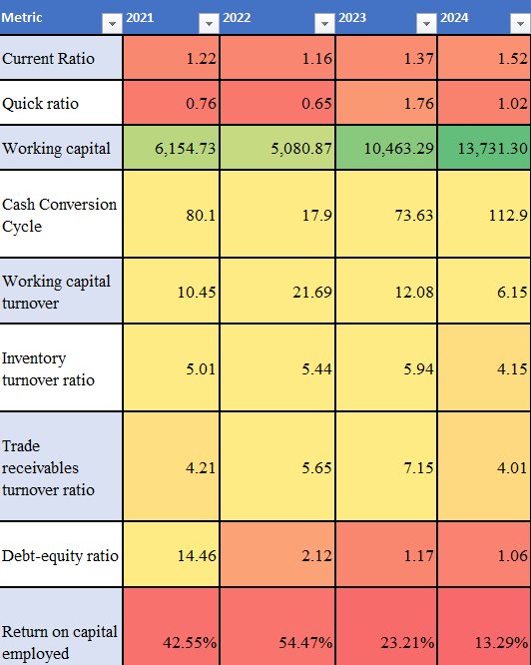

Findings, Recommendations, and Conclusions

a) Results and Findings Relative to Study Objectives
The primary objective of this study was to evaluate HTL Ltd.’s working capital management efficiency over four financial years, identifying trends and operational challenges impacting liquidity, profitability, and cash flow cycles.
- Liquidity and Short-term Financial Health:
The Current Ratio improved steadily from 1.16 (2021-22) to 1.37 (2022-23), surpassing the ideal benchmark of 1, indicating enhanced ability to meet short-term obligations. The Quick Ratio fluctuated but remained close to or above 1.0 in recent years, further corroborating liquidity strength.
- Leverage and Financial Stability:
The Debt-Equity Ratio demonstrated a remarkable decrease, from an alarming 14.46 in 2020-21 to a much healthier 1.17 in 2022-23, signalling a decisive shift toward reduced financial risk and improved capital structure. However, the Debt-Service Coverage Ratio showed a downward trend, implying tighter margins for servicing debt, which warrants caution.
- Operational Efficiency and Working Capital Cycle:
Key operational metrics such as Inventory Turnover and Trade Receivables Turnover reflected mixed results. Inventory Turnover dipped in some periods, suggesting potential overstocking or sluggish inventory movement, while Trade Receivables Turnover improved, indicating more efficient collection processes. The Cash Conversion Cycle extended to 112.9 days in 2024, a signal that HTL faces delays in converting inventory and receivables into cash, impacting liquidity.
- Profitability Metrics:
Return on Equity and Return on Capital Employed exhibited significant declines, highlighting pressures on profitability despite stable or improved operational performance. This may be influenced by increased operating costs or changes in market conditions.

Table 17: Working capital metrics comparison 23-24
Metric | FY 2022–23 | FY 2023–24 | Observation
Working Capital (₹ Cr) | 40.2 | 37.7 | Decreased
Current Ratio | 1.28 | 1.24 | Slightly lower
CCC (Days) | 190.3 | 196.0 | Worsened
Working Capital Turnover | 4.06x | 4.56x | Improved
Receivables Days | 150.1 | 156.2 | Increased
Inventory Days | 112.7 | 113.7 | Flat
These figures clearly reflect a tightening working capital position with slower receivable collections and elevated inventory levels.

b) Conclusions Supported by Findings
- The overall financial health of HTL Ltd. has strengthened with improved liquidity and reduced leverage, a commendable achievement enhancing organizational stability and creditworthiness.
- However, elongated cash conversion cycles and fluctuating profitability ratios reveal underlying inefficiencies in working capital utilization and cost management, which could constrain operational agility.
- The inconsistent inventory turnover points toward a need for better inventory planning and control to avoid capital lockup and reduce holding costs.

c) Recommendations
Based on the findings, the following recommendations are proposed to optimize HTL Ltd.’s working capital management and overall financial performance:
- Optimize Inventory Management:
Implement just-in-time (JIT) inventory systems or enhance demand forecasting to reduce Days Inventory Outstanding and improve turnover ratios, freeing up capital for other uses.
- Accelerate Receivables Collection:
Introduce stricter credit policies and leverage early payment incentives to shorten Days Sales Outstanding, thereby accelerating cash inflows and improving liquidity.
- Extend Payables Without Damaging Supplier Relations:
Negotiate better payment terms with suppliers to increase Days Payable Outstanding, balancing cash outflows while maintaining healthy supplier partnerships.
- Monitor Debt Service Coverage Closely:
Since Debt-Service Coverage Ratio is declining, HTL should carefully plan debt repayment schedules and explore refinancing options to maintain financial flexibility.
- Enhance Profitability Through Cost Control:
Conduct detailed cost audits to identify inefficiencies and implement lean operational practices to reverse profitability declines.

d) Recommendations Accepted by the Organization
The finance team acknowledged the findings and expressed particular interest in recommendations related to inventory and receivables management. The team indicated plans to pilot enhanced inventory controls and tighten credit policies in the next fiscal year, recognizing the potential for substantial cash flow improvements and cost savings.

e) Value to the Organization
This project has provided HTL Ltd. with a clear, data-driven understanding of its working capital dynamics and financial health, serving as a foundation for strategic decision-making. By highlighting strengths and vulnerabilities, the study enables targeted interventions that will improve liquidity, reduce financial risks, and enhance operational efficiency—ultimately contributing to stronger financial resilience and sustained competitive advantage.

References
Fernando, J. (2025, April 6). Working Capital: Formula, Components, and Limitations. Retrieved May 22, 2025, from Investopedia: https://www.investopedia.com/terms/w/workingcapital.asp
Hayes, A. (2025, May 13). Working Capital Management: What It Is and How It Works. Retrieved May 22, 2025, from Investopedia: https://www.investopedia.com/terms/w/workingcapitalmanagement.asp
HTL Ltd. (2022). 61st Annual report 2021-22. Chennai: HTL Ltd. Retrieved May 22, 2025, from https://htllimited.com/uploadimages/230822111208HTL-Financials2021-22.pdf
HTL Ltd. (2023). 62nd Annual report 22-23. Chennai: HTL Ltd. Retrieved May 22, 2025, from https://htllimited.com/uploadimages/210823170838HTLFinancials2022-23.pdf
HTL Ltd. (2024). 63rd Annual report 2023-24. Chennai: HTL Ltd. Retrieved May 22, 2025, from https://htllimited.com/uploadimages/HTL-Financials%202023-24.pdf
OpenAI. (2022, Nov 30).

Appendices

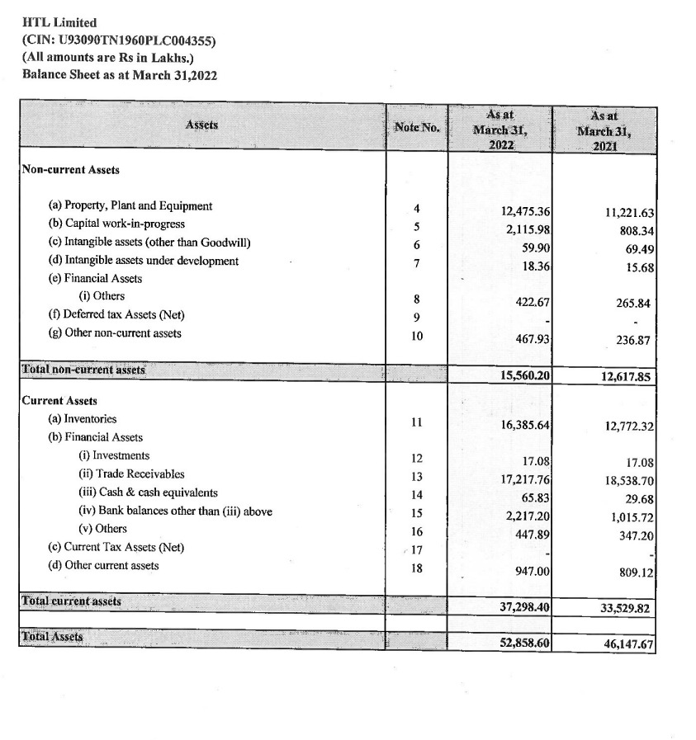
Appendices 1: Balance sheet 2021-22 Assets

Appendices 2: Balance Sheet 2021-22 Liabilities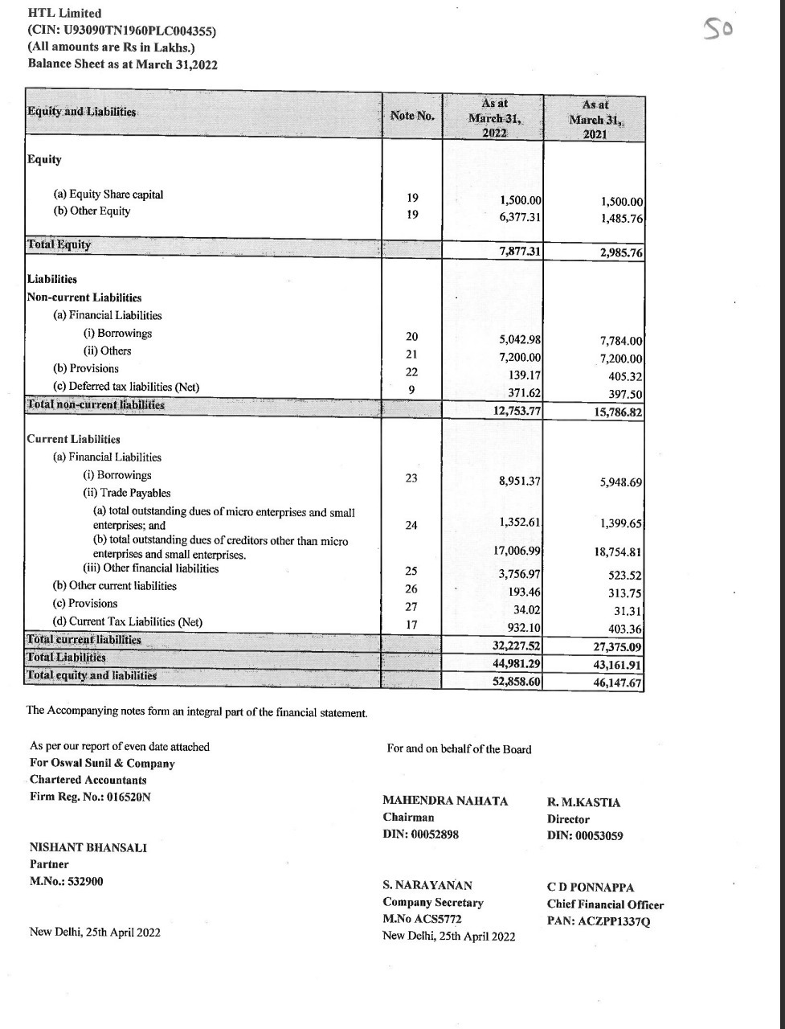Appendices 3: Annual report 2021-22 ratios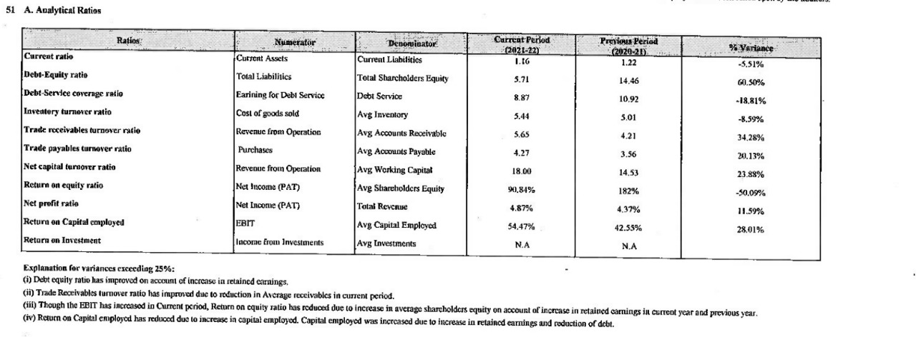
Appendices 4: Income statement 2021-22 revenues and expenses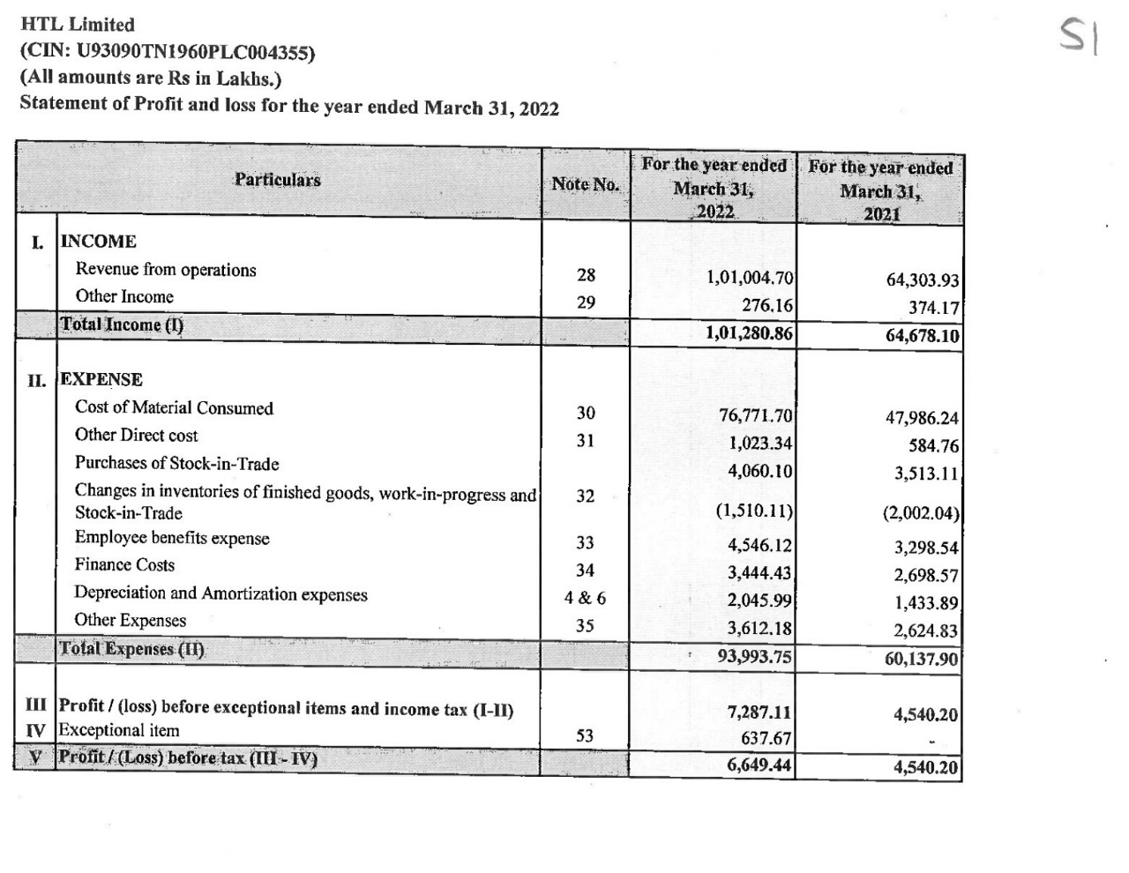
Appendices 5: Balance sheet 2022-23 Assets 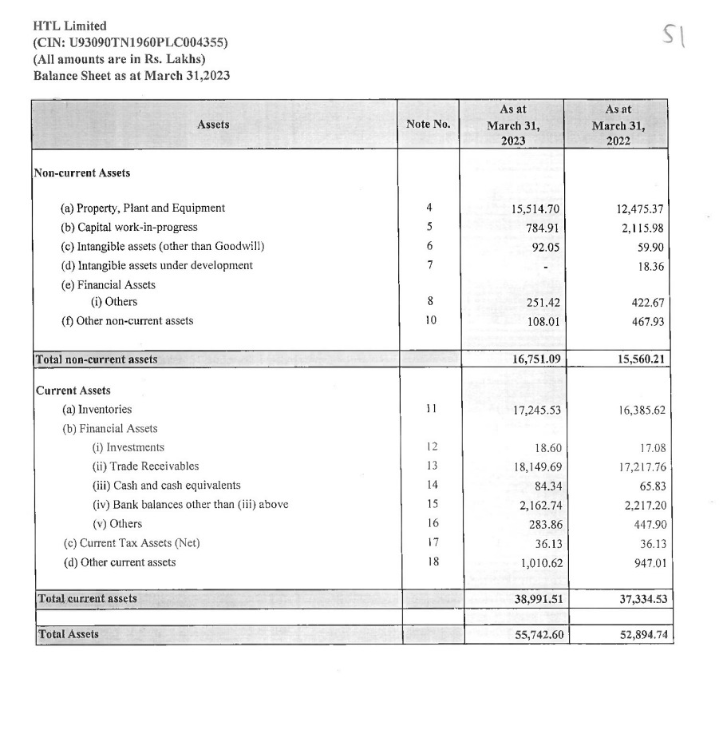
Appendices 6: Balance Sheet 2022-23 Liabilities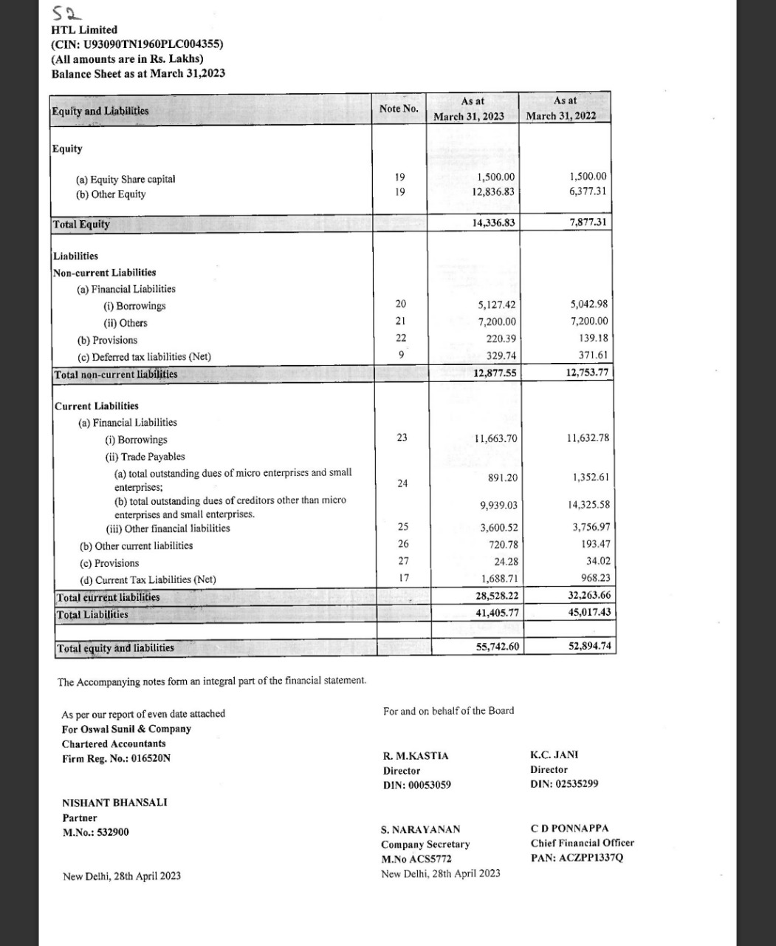
Appendices 7: Annual report 2022-23 Ratios

Appendices 8: Income statement 2022-23 Revenues and Expenses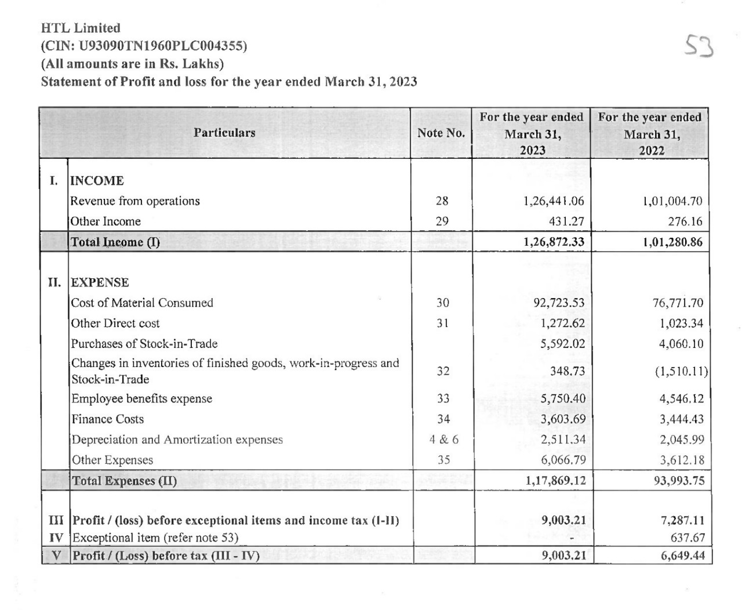

Appendices 9: Balance sheet 2023-24 Assets and Liabilities
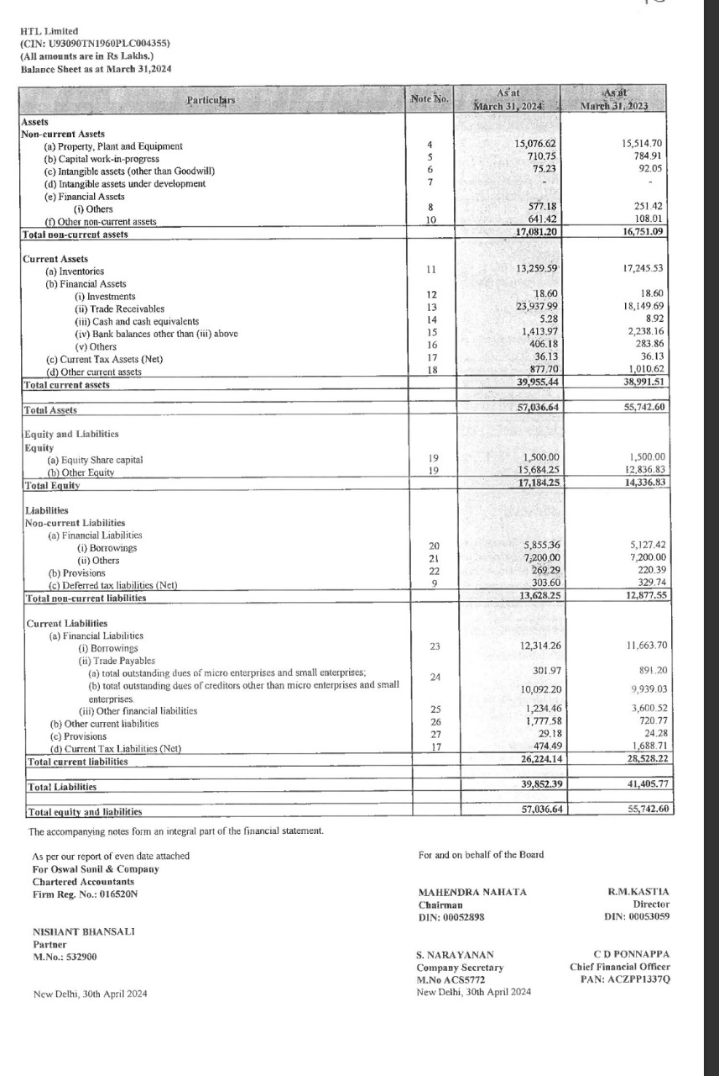
Appendices 10: Income statement 2023-24
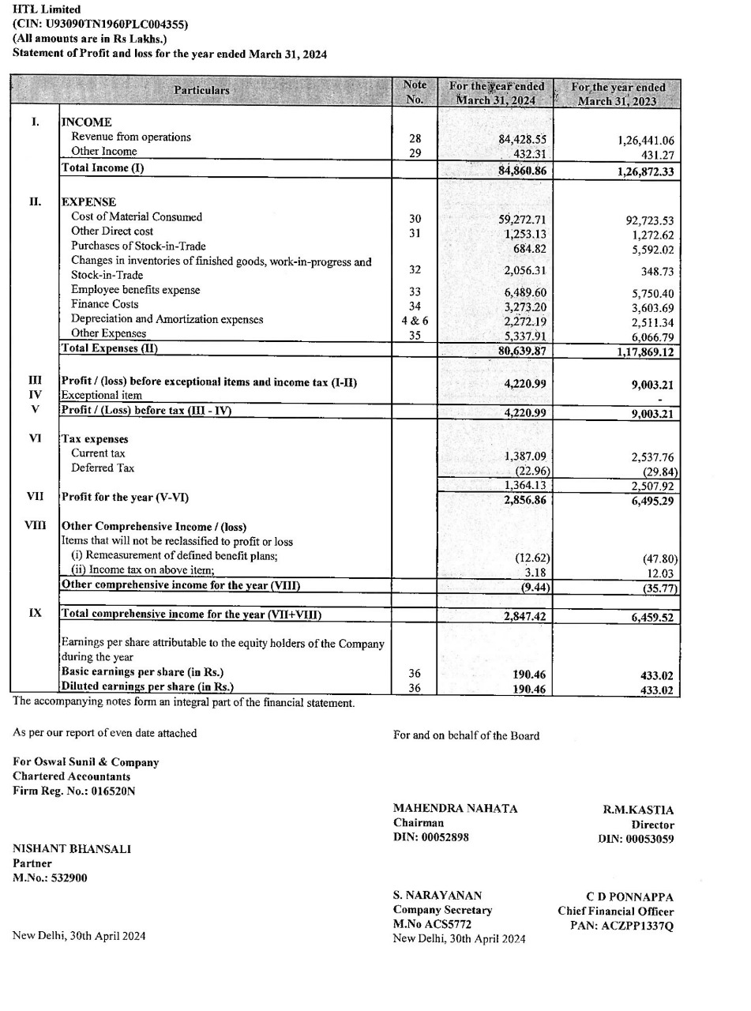
Appendices 11: Annual report 2023-24 ratios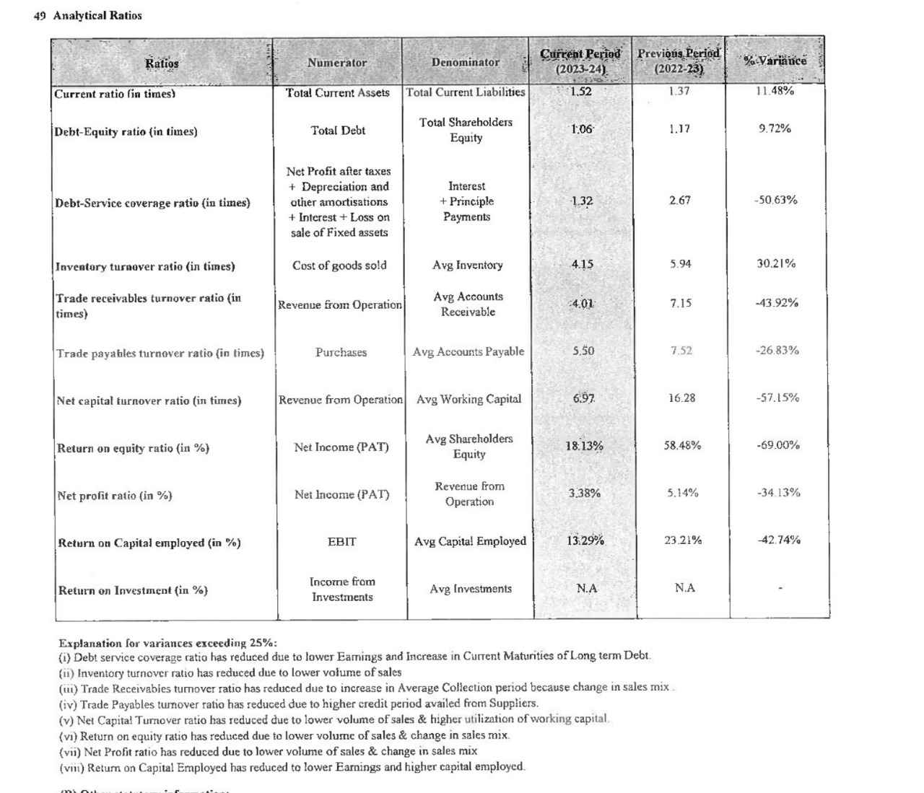

Glossary

Working Capital:
The difference between a company’s current assets and current liabilities. It indicates the liquidity position and operational efficiency of the business.

Working Capital Turnover:
A ratio measuring how efficiently a company uses its working capital to generate sales revenue. Calculated as Net Sales divided by Average Working Capital.

Quick Ratio (Acid-Test Ratio):
A stringent liquidity ratio that measures a company’s ability to meet short-term obligations with its most liquid assets (excluding inventory).

Days Inventory Outstanding (DIO):
The average number of days the company holds inventory before selling it. It reflects inventory management efficiency.

Days Sales Outstanding (DSO):
The average number of days it takes to collect payment after a sale has been made, indicating efficiency in receivables management.

Days Payable Outstanding (DPO):
The average number of days the company takes to pay its suppliers. A longer DPO may improve cash flow but could affect supplier relations.

Cash Conversion Cycle (CCC):
A metric that expresses the time (in days) it takes for a company to convert its investments in inventory and other resources into cash flows from sales.

Operating Cycle:
The total time between purchasing inventory and collecting cash from sales, encompassing both DIO and DSO.

Current Ratio:
A liquidity ratio calculated as current assets divided by current liabilities. It measures a company’s ability to cover short-term obligations.

Debt-Equity Ratio:
A leverage ratio that compares total liabilities to shareholders’ equity, showing how a company finances its assets.

Debt-Service Coverage Ratio (DSCR):
A measure of the company’s ability to cover its debt obligations with its operating income.

Inventory Turnover Ratio:
Shows how many times inventory is sold and replaced over a period, indicating inventory management efficiency.

Trade Receivables Turnover Ratio:
Measures how often a company collects its average accounts receivable during a period.

Trade Payables Turnover Ratio:
Indicates how quickly a company pays off its suppliers.

Net Capital Turnover Ratio:
A ratio showing how efficiently a company utilizes its net working capital to generate sales.

Return on Equity (ROE):
A profitability ratio that measures the return generated on shareholders’ equity.

Net Profit Ratio:
Represents the percentage of revenue that remains as profit after all expenses.

Return on Capital Employed (ROCE):
Measures profitability and efficiency in capital utilization, calculated as EBIT divided by capital employed.

Return on Investment (ROI):
A performance measure used to evaluate the efficiency of an investment.

HTL Ltd.:
An Indian multinational company specializing in cable manufacturing and power transmission solutions, known for its strong presence in both domestic and international markets.

Working Capital Management:
The process of managing the short-term assets and liabilities to ensure a company maintains sufficient liquidity to run day-to-day operations smoothly.

Liquidity:
The ability of a company to meet its short-term financial obligations.

Leverage:
The use of borrowed funds (debt) to finance the company’s operations and growth.

Operating Income (EBIT):
Earnings Before Interest and Taxes; a measure of a company’s profitability from operations.

Financial Ratios:
Quantitative measures derived from financial statements used to assess various aspects of a company’s performance such as liquidity, profitability, and solvency.

